VAMSIKRISHNA I

421118104093

lll-CSE-C

FLOW CONTROL ASSIGNMENT - PART – 2

8

import java.util.\*;

class Main8

{

public static void main(String[] args)

{

Scanner sc = new Scanner(System.in);

System.out.println("R-Red,G-Green,O-Orange,Y-Yellow,W-White");

char a;

a = sc.next().charAt(0);

switch(a)

{

case 'R':

System.out.println("Red");

break;

case 'G':

System.out.println("Green");

break;

case 'O':

System.out.println("Orange");

break;

case 'Y':

System.out.println("Yellow");

break;

case 'W':

System.out.println("White");

break;

default:

System.out.println("Invalid code");

}

}

}

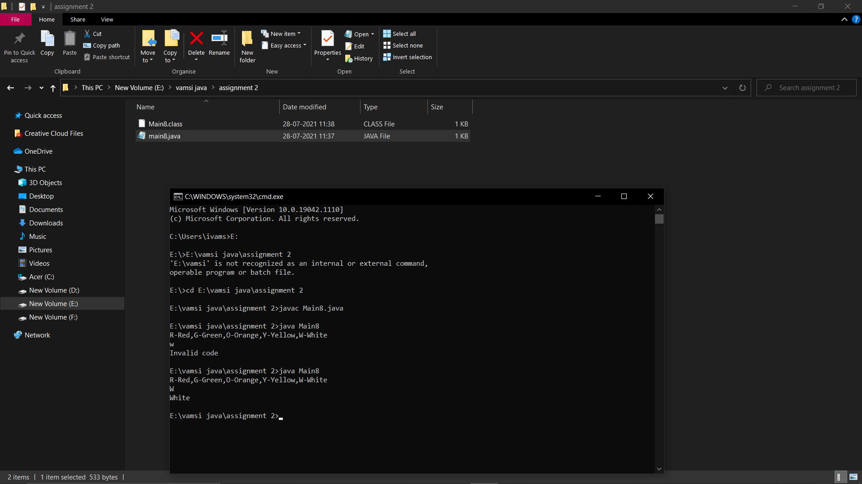

9

import java.util.\*;

class Main9

{

public static void main(String[] args)

{

int a = Integer.parseInt(args[0]);

if(args[0]!= null)

{

switch(a)

{

case 1:

System.out.println("January");

break;

case 2:

System.out.println("February");

break;

case 3:

System.out.println("March");

break;

case 4:

System.out.println("April");

break;

case 5:

System.out.println("May");

break;

case 6:

System.out.println("June");

case 7:

System.out.println("July");

break;

case 8:

System.out.println("August");

break;

case 9:

System.out.println("September");

break;

case 10:

System.out.println("October");

break;

case 11:

System.out.println("November");

break;

case 12:

System.out.println("December");

break;

default:

System.out.println("Invalid code");

}

}

else

{

System.out.println("Please the month in numbers");

}

}

}

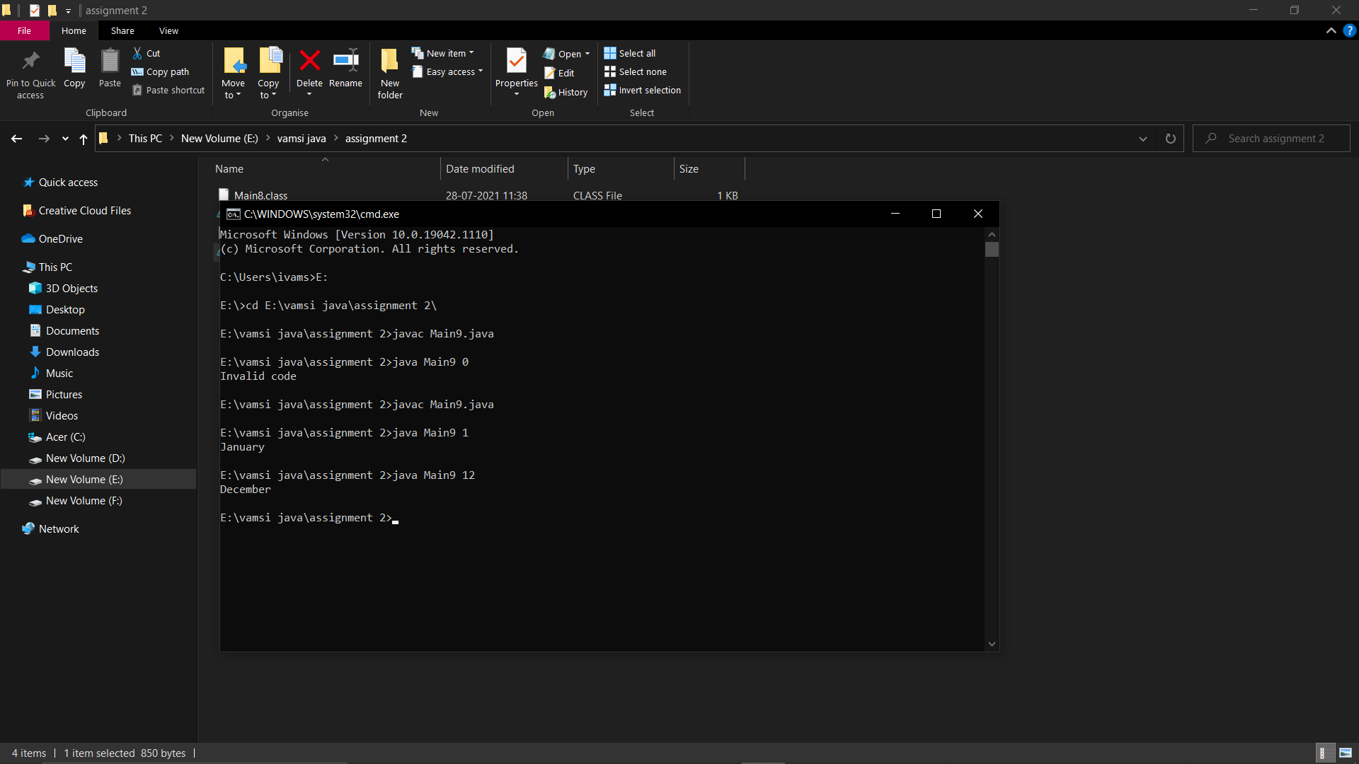

10

import java.util.\*;

class Main10

{

public static void main(String[] args)

{

Scanner sc=new Scanner(System.in);

int n=sc.nextInt();

for(int i=1;i<=n;i++)

{

System.out.print(i);

System.out.print(" ");

}

}

}

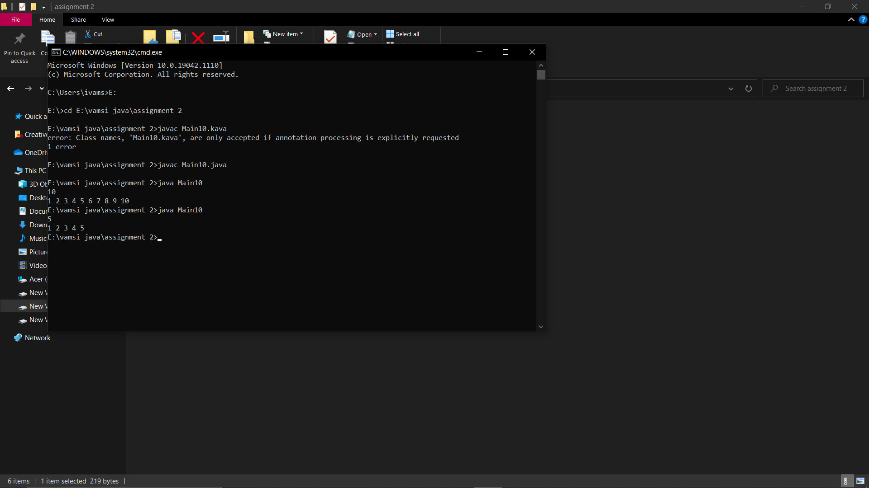

11

import java.util.\*;

class evenrange

{

public static void main(String[] args)

{

int n=57,i;

Scanner sc=new Scanner(System.in);

for(i=23;i<=n;i++)

{

if(i%2==0)

{

System.out.println(i+" ");

}

}

}

}

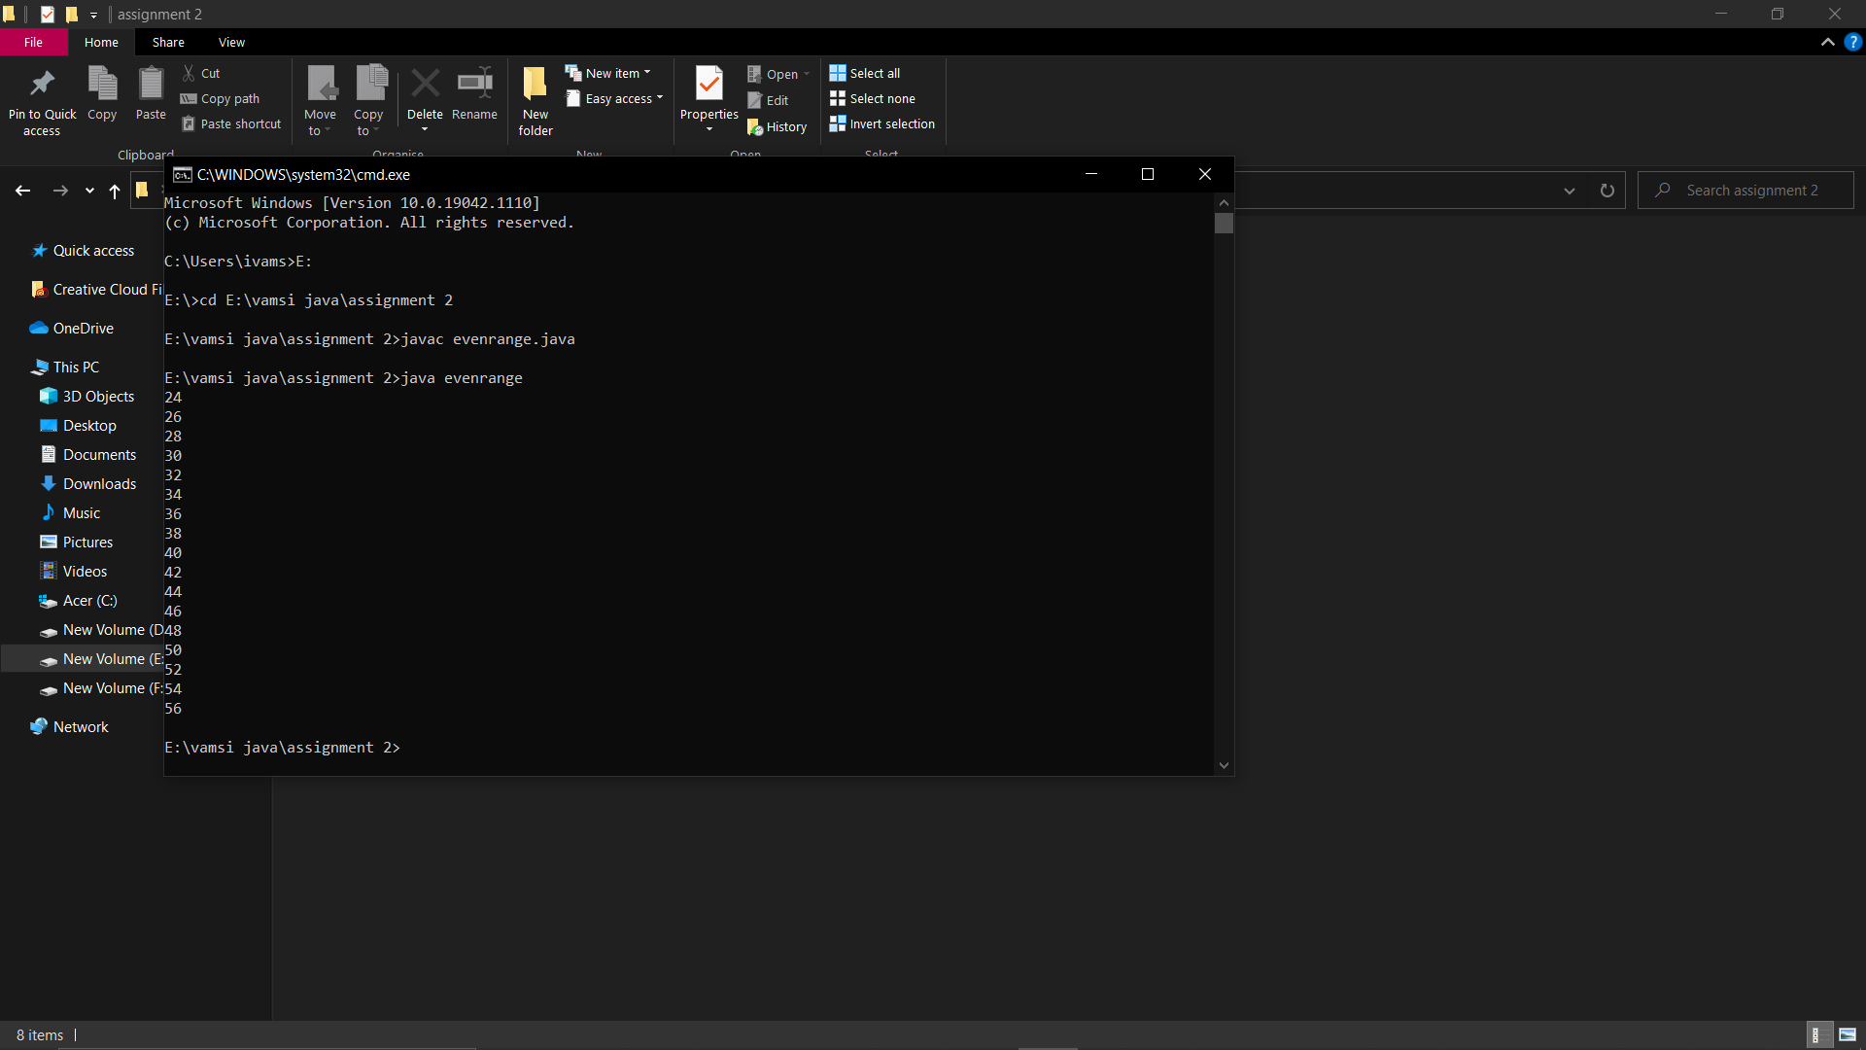

12

import java.util.\*;

class Main12

{

public static void main(String[] args)

{

Scanner sc=new Scanner(System.in);

System.out.print("Enter number: ");

int n=sc.nextInt();

int c=0;

sc.close();

for(int i=2;i<=n/2;i++)

{

if(n%i==0)

{

c++;

break;

}

}

if(c==0)

{

System.out.print("Prime number");

}

else

{

System.out.print("Not a prime number");

}

}

}

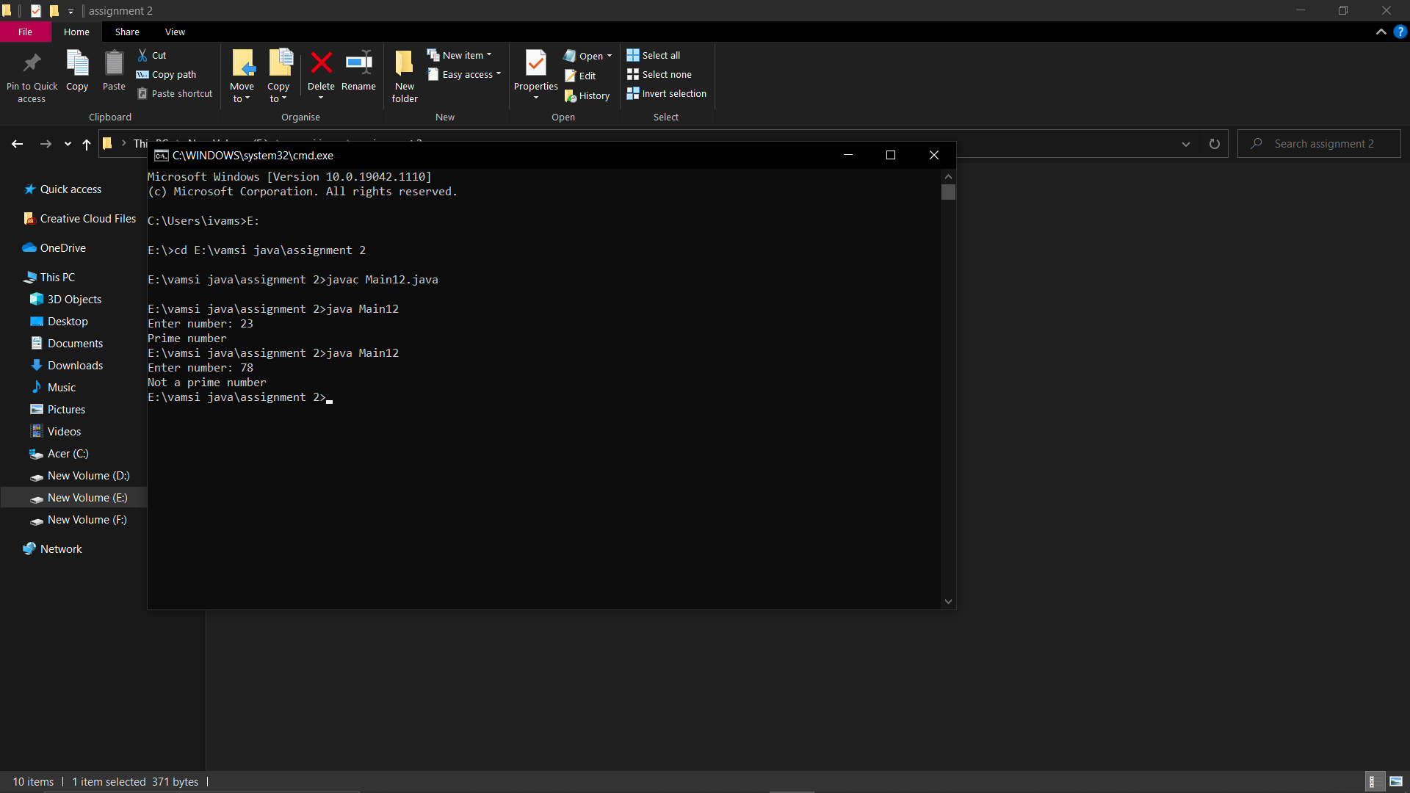

13

import java.util.\*;

class prime

{

public static void main(String[] args)

{

int a=10,b=99;

while(a<b)

{

boolean flag=false;

for(int i=2;i<=a/2;i++)

{

if(i%2==0)

{

flag=true;

break;

}

}

if(!flag && a!=0 && a!=1);

System.out.print(a+" ");

++a;

}

}

}

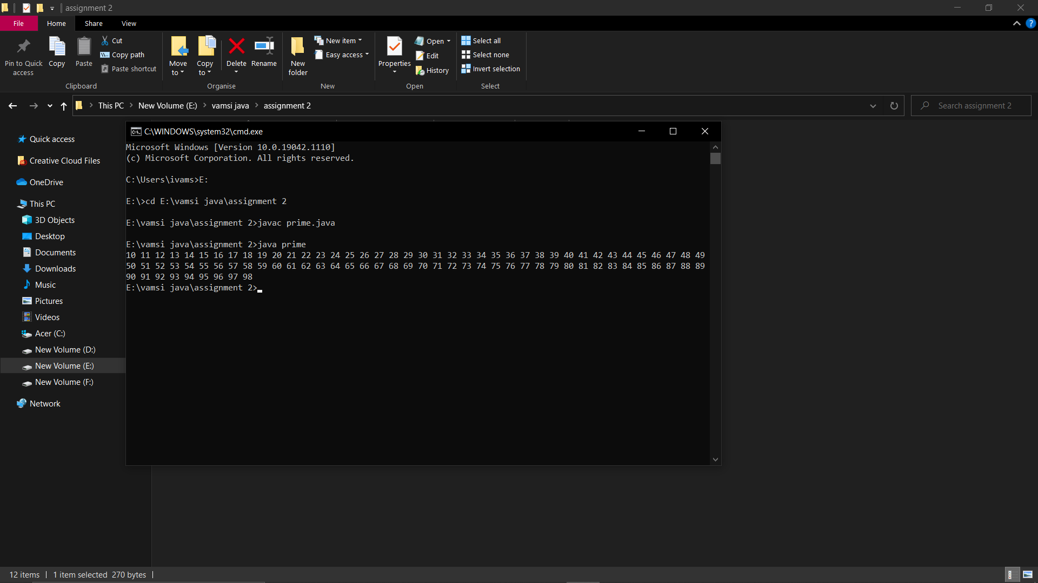

14

import java.util.\*;

class Sum

{

public static void main(String[] args)

{

int m,n,sum=0;

Scanner sc=new Scanner(System.in);

System.out.println("enter number:");

m=sc.nextInt();

while(m>0)

{

n=m%10;

sum=sum+n;

m=m/10;

}

System.out.println("sum="+sum);

}

}

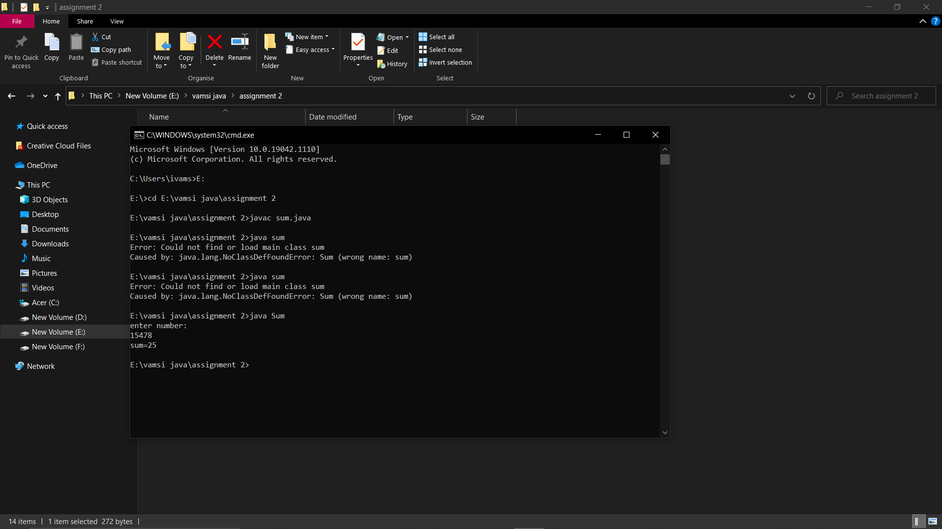

15

import java.util.\*;

class Pattern

{

public static void main(String[] args)

{

int n,i,j;

Scanner sc=new Scanner(System.in);

System.out.println("enter number:");

n=sc.nextInt();

for(i=0;i<n;i++)

{

for(j=0;j<i;j++)

{

System.out.print("\* ");

}

System.out.println();

}

}

}

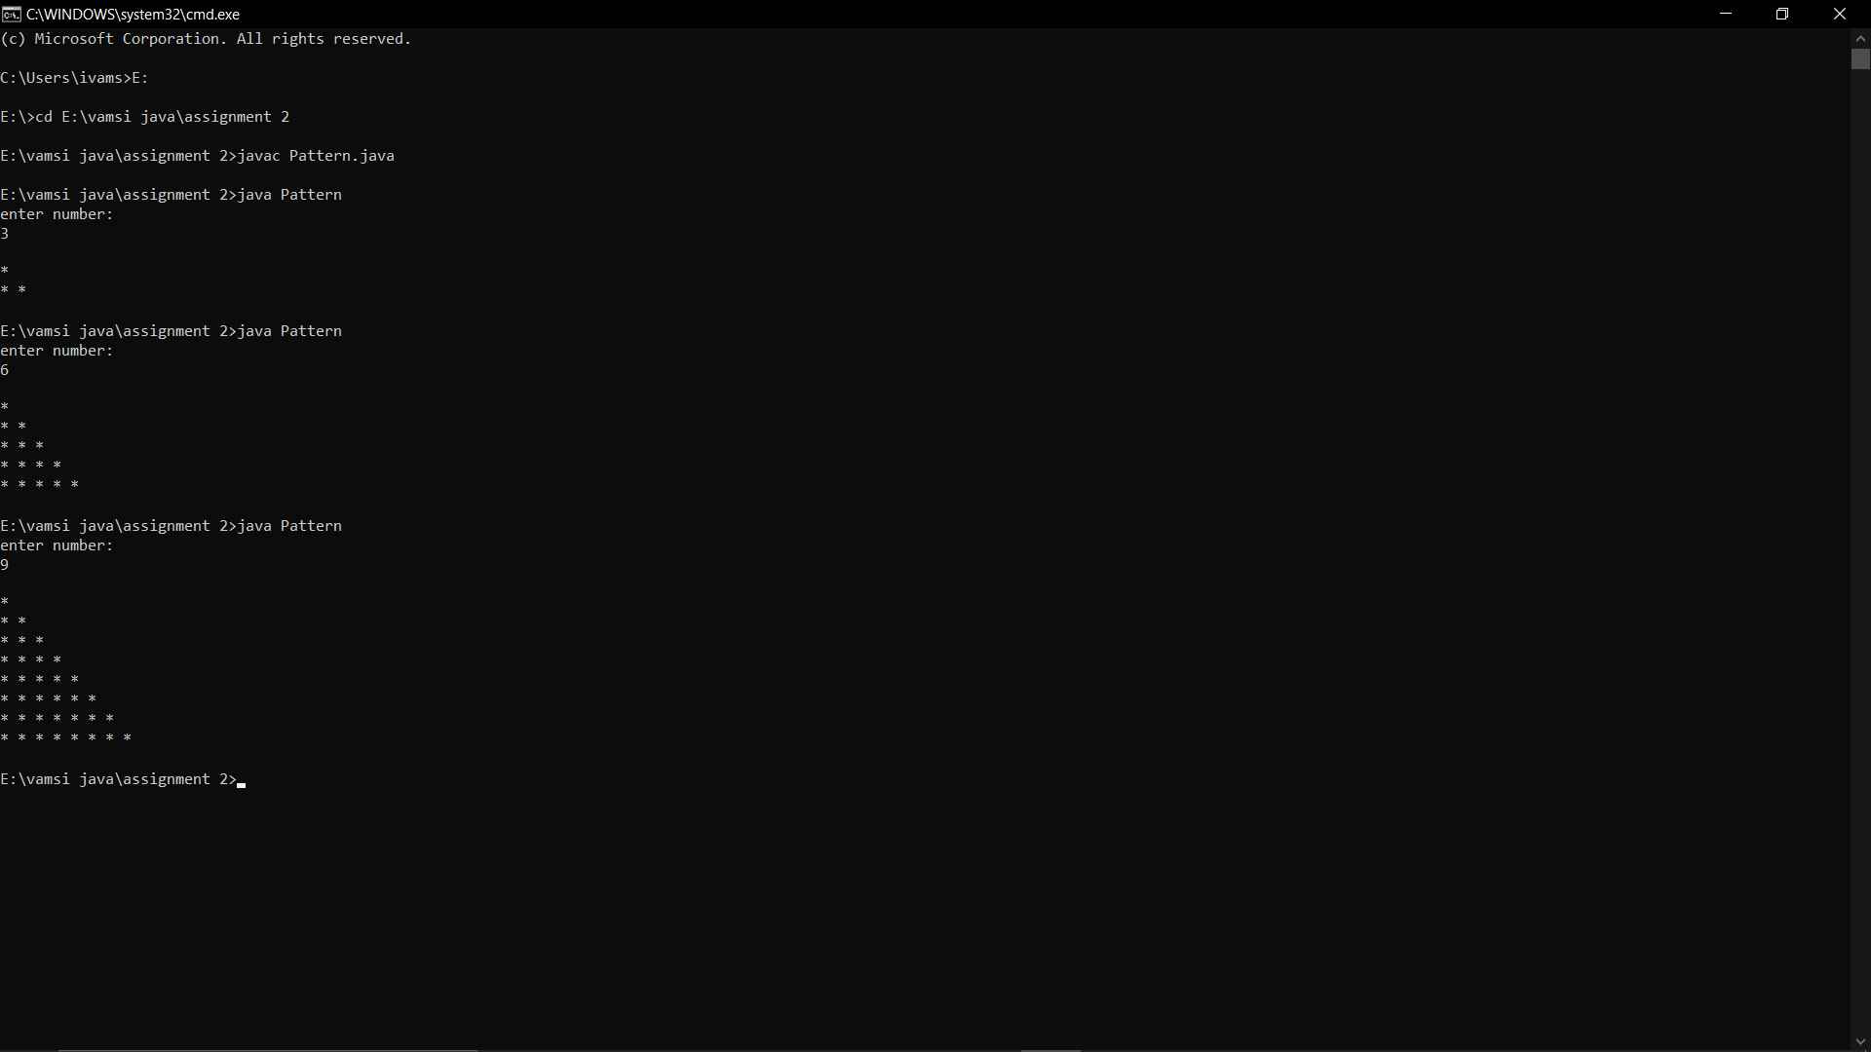

16

import java.util.\*;

class Rev

{

public static void main(String[] args)

{

int n,r=0;

Scanner sc=new Scanner(System.in);

System.out.println("enter number:");

n=sc.nextInt();

while(n>0)

{

r=r\*10;

r=r+n%10;

n=n/10;

}

System.out.println("Reverse="+r);

}

}

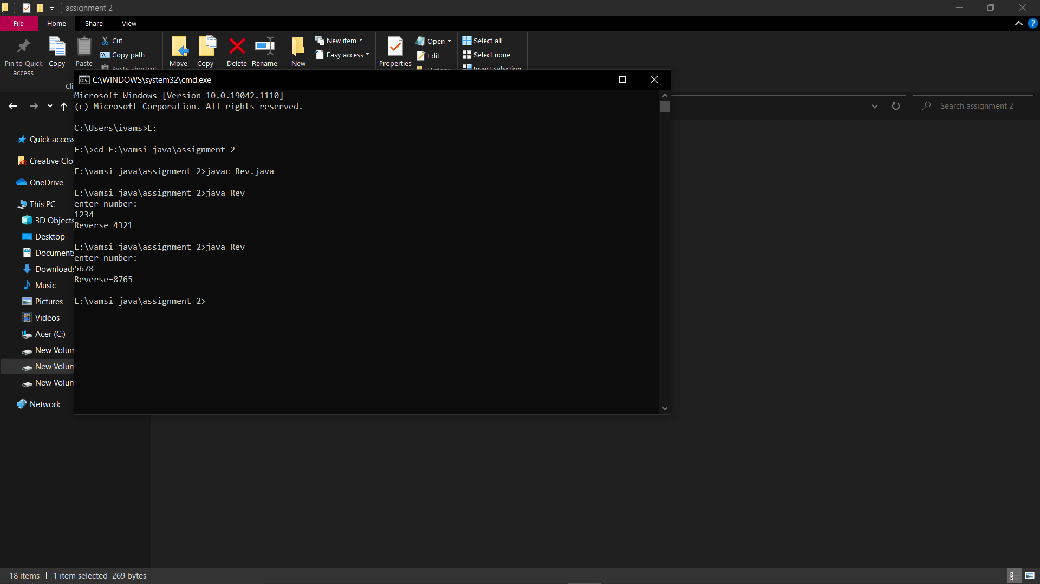

17

class Main17

{

public static void main(String args[])

{

int n = Integer.parseInt(args[0]);

int r,sum=0,t;

t=n;

while(n>0)

{

r=n%10;

sum=sum\*10+r;

n=n/10;

}

if(t==sum)

System.out.println("Palindrome");

else

System.out.println("Not a Palindrome");

}

}

